CPU College

Bsc Project
Title:Design and implementation of a tender processing system

Group Member Name ID.No
- Rohawit Fentaw ……………………………. ……. ECS/214/13
- Eden Mekonnen……………………………………. ECS/828/13
- Ananaya Amare……………………………………… ECS/827/13
- Fitsum dereje ……………………………………….. ECS 1089/13

Advisor: Mr. Kibrom

Chapter 1 Introduction

1.1 Introduction
In modern procurement practices, transparency, efficiency, and fairness are essential for the successful delivery of goods, services, and infrastructure projects. The tendering process, a fundamental component of public and private procurement, is designed to ensure competitive bidding, objective evaluation, and value for money. Yet, in many developing countries, including Ethiopia, procurement operations are still conducted using traditional, paper-based systems or fragmented digital tools. These outdated approaches introduce major inefficiencies—ranging from delays and human errors to a lack of auditability and increased risk of corruption (World Bank, 2020).
With the global shift toward e-governance, digital solutions have become increasingly vital for streamlining procurement workflows. Implementing a fully automated tender processing system can eliminate many of the limitations of manual processes by offering features such as real-time updates, traceable workflows, and automated bid evaluations. These systems not only improve operational performance but also enhance accountability and build trust among suppliers, regulators, and the public (OECD, 2021; UNDP, 2022).
Public procurement is a cornerstone of government operations and plays a vital role in delivering infrastructure, public services, and economic development. The tendering process, as part of procurement, is designed to promote fair competition, transparency, and value for money. However, in many developing countries such as Ethiopia, this process is still handled manually or through disconnected systems, leading to inefficiencies, lack of transparency, and vulnerability to corruption (World Bank, 2015). A key issue in Ethiopia’s current procurement landscape is the dominance of price over quality in bid evaluations. As Kozik (2019) explains, tender evaluations—particularly in infrastructure and construction—should ideally consider both price and non-price criteria such as technical competence, time of execution, and proposal quality. However, in practice, procurement authorities often give the maximum legally allowed weight (60%) to price, which limits the effectiveness of evaluating more holistic and sustainable contractor proposals.
The inefficiencies of manual systems include document duplication, delays in bid submission and evaluation, and increased opportunities for manipulation or favoritism. In addition, the lack of digital records and audit trails makes it difficult to verify decisions or ensure compliance with procurement regulations (OECD, 2009). This undermines trust in procurement outcomes and hinders institutional accountability. To overcome these limitations, several researchers and international organizations have recommended the adoption of digital tools such as e-tendering systems, decision support tools, and automated evaluation mechanisms (Deshpande et al., 2018; Abdullahi et al., 2019).
These tools enhance transparency, speed up procurement cycles, and reduce administrative burdens. Despite global trends toward digitization, practical implementation in Ethiopia remains limited. This is largely due to infrastructural gaps, lack of trained personnel, and budget constraints (UNCTAD, 2017). These challenges underscore the need for context-specific, cost-effective digital solutions that can be adopted gradually by institutions.
This project proposes the design and implementation of a web-based Tender Processing System tailored to the Ethiopian procurement context. The system will automate the full tender lifecycle—from bid announcement and submission to evaluation and award—while supporting multi-criteria evaluation in line with legal frameworks such as Ethiopia’s Public Procurement Proclamation No. 649/2009. By increasing transparency, reducing processing time, and ensuring compliance, this system will significantly contribute to better procurement governance and institutional efficiency.
1.2 Motivation of the study
The motivation behind this study arises from the growing challenges and inefficiencies within traditional tendering processes, particularly in organizations that still rely on manual and paper-based systems. These systems are often prone to delays, human errors, lack of transparency, and a high degree of subjectivity in bid evaluation, leading to biased outcomes. In addition, manual tendering processes often result in high administrative costs and lengthy procurement cycles, reducing overall operational efficiency. As organizations, both in the public and private sectors, strive to enhance their procurement practices and improve transparency, there is a clear need for an automated tender processing system. The motivation for this study is to address these challenges by designing a solution that automates the entire tendering process—from bid submission to evaluation and award decisions—ensuring greater efficiency, fairness, and compliance with procurement regulations. With increasing reliance on digital solutions across various sectors, this study seeks to explore how automation can streamline procurement workflows, reduce human error, and minimize the time required for tender processing. The implementation of such a system will not only save time and reduce operational costs but also enhance transparency, foster trust among stakeholders, and improve accountability in procurement processes. This study is driven by the need to create a more efficient, cost-effective, and transparent system that meets modern standards of procurement
1.3 Statement of the Problem
Despite improvements in technology access, Ethiopia’s procurement systems remain largely manual and outdated. This causes several critical issues:
- Time-consuming Processes: Paper-based tendering requires physical distribution, submission, and evaluation of bids, which leads to significant delays—especially for large-scale infrastructure or emergency procurement.
- Limited Accessibility: Suppliers located far from major cities often miss opportunities due to the need to be physically present to access and submit bids.
- Lack of Transparency: With no centralized digital records, there's little visibility into how decisions are made. This can lead to mistrust between organizations and bidders, and opens the door to corruption.
- Administrative Burden: Government offices and private companies spend substantial time and money managing printed documents, archiving bid files, and handling manual evaluations.
These issues show the need for a modern, web-based tendering system that supports Ethiopia’s broader goals of efficiency, transparency, and digital public service delivery.
Many public institutions still rely on manual tender processing methods that are prone to inefficiencies, errors, and bias. These outdated processes hinder transparency, slow down project implementation, and often fail to meet the evolving demands of modern procurement systems. Additionally, the absence of digital systems makes it difficult to fairly and consistently evaluate tenders using both price and non-price criteria. There is a clear need for an automated system that can standardize and improve the efficiency of tender processing in public procurement.
1.4 Objectives
1.4.1 General Objective
To design and implement a web-based Tender Processing System that automates the tender lifecycle and enhances transparency, efficiency, and compliance in public procurement.
1.4.2 Specific Objectives
To develop a platform for tender announcement and bid submission
- To implement a customizable evaluation engine supporting multi-criteria assessments
- To automate scoring and ranking of tenders based on predefined rules
- To facilitate transparent awarding and documentation of tender processes
- To provide user dashboards for different roles (e.g., admin, evaluator, contractor)
1.5 Scope and limitation
1.5.1 scope
This section defines the boundaries and assumptions of the project, and the factors or constraints that may affect its execution or results
This project will design and implement a web-based system that supports the entire tender process from creation to awarding. It will include modules for user registration, tender creation, bid submission, multi-criteria evaluation, and result publication. The system will not include modules for contract management or payment processing in this phase.
- Online tender posting, submission, evaluation, and awarding
- Secure vendor registration and document upload
- User role management (admin, evaluator, vendor)
- Report generation and submission tracking
1.5.2 Limitations of the Project
- No integration with payment gateways
- No real-time messaging between users
- Evaluation still relies on human scoring, which may include bias
- Only selected document formats (PDF, DOCX) are supported
- Single-language interface (English)
- Internet access is required to use the system
1.6 Delimitations
- The system is designed for small to medium organizations, not large-scale government or international tendering
- Focuses only on the core tender lifecycle: posting, submission, evaluation, and awarding
- It excludes financial management, legal review, or automated dispute resolution.
- Designed only in English and does not support multilingual interfaces or accessibility tools for users with disabilities
1.7 Assumptions and Constraints
1.7.1 Assumptions
- All users will have access to the internet and a digital device (laptop/PC)
- Users have the basic skills required to register, log in, and upload documents
- Tender processes follow a predictable and standardized format
- Users (especially evaluators) will behave ethically and fairly when using the system
- Hosting resources and development tools will be available throughout the project
- System usage will be moderate and not involve very high traffic at the initial phase
1.7.2 Constraints
- The system cannot function without reliable internet access
- Limited file size and type due to storage and security constraints
- Project development must be completed within an academic timeline
- All users must have basic computer literacy to interact with the system
1.8 Tools and Methodologies
To extract data which is the main input for the project, collection techniques will be used. data document analysis because it’s easy to get full and exact information about their existing system. Data collection is one of the important tasks in determining and analyzing the existing system
1.8.1 Data Analysis
Collected data will be analyzed to determine user roles, system requirements, and workflow. Redundancies and inefficiencies in the current manual process will be identified for automation.
1.8.2 System Modeling
Design diagrams such as Data Flow Diagrams (DFDs), Entity-Relationship Diagrams (ERD), and Use Case diagrams will be used to model system functionality, data storage, and interactions.
Fig. 1 Design and Implementation of a Web-Based Tender Processing System

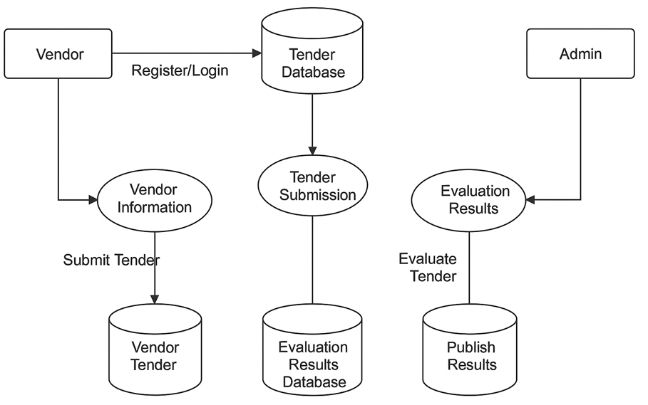

1.8.3 System Development
An agile-based development approach will be used. The system will be developed in stages (modules), allowing for feedback and incremental improvements. Technologies include PHP/Python, MySQL/PostgreSQL, HTML/CSS, and JavaScript.
1.8.4 Testing
Testing will include unit testing (individual modules), integration testing (combined modules), and User Acceptance Testing (UAT). Bug tracking tools will be used to ensure quality control.
1.8.4. Deployment
The system will initially be deployed on a local or demo server for evaluation. If resources allow, deployment on a live server will follow for real-world testing.
1.8.5 Development tool
- For Documentation
- Microsoft Word/Google Docs – For creating detailed reports, proposals, and manuals
- Microsoft PowerPoint – For creating visual diagrams, flowcharts, and system designs
- Google Drive – For storing and sharing your documents

- For Implementation
- HTML/CSS/JavaScript – For building the user interface
- PHP – For backend logic and server-side processing
- MySQL – For database storage
- XAMPP – For local server setup (includes Apache, PHP, MySQL)
- Visual Studio Code – For code writing and editing
- Google Chrome – For testing and running the system in a browser
1.9 Significance and Beneficiaries of the project
1.9.1 Significance of the project
The significance of this study lies in the development of an automated tender processing system aimed at addressing critical inefficiencies in the traditional procurement process. Currently, manual systems are prone to delays, human errors, and lack of transparency, often leading to biased tender outcomes and difficulties in ensuring compliance with procurement regulations. The proposed system will streamline the entire tendering process by automating bid submission, evaluation, and award phases. This automation will lead to significant time savings and cost reduction for organizations, allowing procurement teams to focus on strategic tasks. Moreover, by incorporating features such as audit trails, reporting tools, and real-time updates, the system will ensure transparency, which will help build trust among suppliers and stakeholders. Additionally, the system’s ability to ensure compliance with local and international procurement regulations will mitigate the risk of legal challenges. Ultimately, this study will contribute to the enhancement of procurement efficiency, transparency, and accountability, benefiting both public and private sector organizations.
1.9.2 Beneficiaries of the project
There are different bodies that will benefit from this system. The main beneficiaries of this system include
1. Public and Private Organizations (Procurement Departments)
- Improved Efficiency: Automated processes will streamline the entire procurement workflow, reducing the time required for each phase (bid submission, evaluation, award) and enabling procurement teams to focus on more strategic tasks
- Cost Savings: The reduction in administrative tasks will lead to lower operational costs
- Better Resource Allocation: Procurement teams can allocate more time to high-value activities instead of administrative work
- Transparency and Accountability: Automated tracking and reporting will enhance transparency, building trust among suppliers and stakeholders
2. Government Entities and Regulatory Bodies
- Regulatory Compliance: The system will ensure compliance with local and international procurement laws, minimizing the risk of legal challenges
- Improved Oversight: Easier monitoring of the entire procurement process will ensure that regulations and standards are adhered to
- Transparency: Audit trails and real-time updates will provide full visibility into the procurement process, allowing for better oversight
3. Suppliers and Vendors
- Fair and Transparent Tendering: Suppliers will benefit from an unbiased, transparent system that allows for equal opportunities during the tender process
- Faster Processing: The automated system will speed up the evaluation and awarding process, allowing suppliers to get results more quickly
- Reduced Errors: Automation will reduce human errors in bid evaluation, ensuring more accurate decisions and fewer disputes
4. Employees and Staff Involved in Tendering
- Reduced Workload: By automating repetitive tasks, employees will be able to focus on more value-added activities, thus reducing the burden of manual work
- Training and Skill Development: Employees will have the opportunity to learn and develop skills related to modern software tools and systems, boosting their professional growth
5. External Stakeholders (e.g., NGOs, Donors, Contractors)
- Access to Reliable Data: External stakeholders, such as donors or contractors, will have access to real-time data, enabling more informed decisions during the procurement process
- Better Collaboration: A centralized platform for tender management will enhance collaboration between procurement teams and external partners
6. Customers/End Users (Indirect Beneficiaries)
- Better Quality Goods and Services: By selecting the best suppliers through a transparent, automated process, the quality of goods and services will be improved, benefiting customers
- Cost Efficiency: With reduced procurement costs, organizations can potentially pass on savings to customers, improving overall value for money
7. Academic Community and Researchers
- Contribution to Knowledge: This study will contribute valuable insights into the design and implementation of automated tendering systems, which can be referenced by future academic research
- Case Study: The project may serve as a case study for other researchers studying automation in procurement systems
8. The Broader Community (Society)
- Fairer Distribution of Public Resources: Transparent procurement processes ensure that taxpayer money is used efficiently, contributing to better public services
- Reduced Corruption: By eliminating the possibility of human biases and manipulation, the system will help reduce corruption in the tendering process,
- fostering a more ethical environment
1.10 Work breakdown
1.10.1 Required resources with cost
Resources | Unit | Unit | Quantity | Cost(birr)
HARDWARE cost | Flash | Number | 2(8GB) | 600
HARDWARE cost | Computer(pc) | Number | 1 | 60000
Writing tool | Paper | Number | 200 | 1000
Writing tool | Pen | Number | 4 | 200
Total |  |  |  | 61700

1.10.2 Task and Schedule
Tasks | April 1st –April 29th | April 20 – April 29th | April 30th – may 29th | May 30th- june 4th | jun 5th -Jun 30th
Planning and analysis phase
Design and Development Phase
Implementation and Testing Phase
User Feedback and Refinement Phase
Finalization and Deployment Phase

Chapter Two- Requirement Analysis
2.1 Introduction
This chapter focuses on analyzing and gathering the necessary requirements for designing and implementing the proposed tender processing system. Requirement analysis is a critical phase in system development, as it lays the foundation for the entire project by identifying what the system should do and how it should perform. The purpose of this chapter is to understand the limitations of the current system and clearly define the goals and expectations for the new system.
The chapter begins by presenting an overview of the current tendering system, including its challenges and inefficiencies. It then introduces the proposed system and outlines its major functional and non-functional requirements. In addition, this chapter includes essential modeling tools such as use case diagrams, user interface prototypes, and sequence diagrams to visualize the system’s behavior and interactions. Business rules, constraints, and change cases are also discussed to ensure that the system meets both user needs and organizational standards. By the end of this chapter, a comprehensive understanding of what the system should deliver will be established, guiding the design and implementation in the subsequent phases.
2.2 Current System Overview
The current tender processing system in many public and private organizations, particularly in developing countries, is predominantly manual or semi-digital. In this system, tender announcements are typically published via newspapers, printed posters, notice boards, or through institutional websites in PDF format. Vendors who wish to participate in the tender process are required to physically collect the tender documents or download them from the website. Bid submission is also often done manually—bidders submit sealed envelopes containing technical and financial proposals to the office of the procuring entity.
This approach has several limitations. First, it is time-consuming and resource-intensive for both the procuring entity and the bidders. Collecting physical documents, traveling to submit proposals, and handling paperwork adds significant overhead. Second, the lack of automation leads to inefficiencies in bid management, evaluation, and communication. Evaluation committees must manually review and score each submission, which can take days or weeks, often resulting in delays in contract awards.
Another major issue is limited transparency. Without digital tracking and audit trails, the process is vulnerable to human error, favoritism, and corruption. It becomes difficult to prove that all bidders were treated fairly or that the evaluation process followed standardized criteria. In some cases, information asymmetry may occur, where certain bidders have better access to documents or updates than others. Moreover, communication between stakeholders (e.g., procurement officers, evaluators, and bidders) is typically conducted via email or phone calls, making it difficult to track the status of tenders and interactions. There is also no centralized platform where vendors can view open tenders, check submission deadlines, or get automated notifications.
In summary, the existing tender processing system suffers from several critical challenges that hinder its efficiency and effectiveness. One of the major issues is the reliance on manual document handling and storage, which increases the risk of misplacement, loss, or damage of important bid documents. Additionally, the process is vulnerable to bid tampering and lacks mechanisms for ensuring data integrity. The absence of real-time updates and automated notifications creates communication gaps between the procuring entities and bidders, often leading to confusion or missed deadlines. Moreover, bid evaluation and contract awarding are frequently delayed due to the time-consuming nature of manual reviews. The system also lacks centralized monitoring and reporting tools, making it difficult to track the progress and performance of tenders. Lastly, the limited accessibility of the system poses challenges for remote or international bidders, reducing the inclusiveness and competitiveness of the tendering process.
2.3 Proposed System Overview
The proposed system is a web-based tender processing platform designed to automate the entire tendering lifecycle, from tender creation and bid submission to evaluation and award. It will provide a centralized interface for administrators and registered bidders, ensuring accessibility, transparency, and security. The system will also generate reports and allow for the monitoring and aud The proposed system is a web-based tender processing system designed to address the major limitations and inefficiencies of the existing manual or semi-digital tendering methods. The goal of the new system is to automate and streamline the entire tender lifecycle—from tender announcement to bid submission, evaluation, and contract awarding—while ensuring security, transparency, and ease of use for all stakeholders.
The system will consist of two main user types: Administrators (Procurement Officers) and Vendors (Bidders). Each user will interact with the system through secure login credentials. Administrators will be able to create, manage, and publish tender notices, set deadlines, upload relevant documents, and evaluate bids submitted by vendors. Vendors will be able to register on the platform, view available tenders, download tender documents, submit bids, and track the status of their submissions in real time. To promote transparency and reduce bias, the system will maintain a centralized database where all tenders, user activities, and bid records are stored and time-stamped. This database will allow the system to generate audit logs and reports that can be used for accountability and monitoring purposes. Automated notifications and reminders will be integrated to alert vendors of new tenders, approaching deadlines, or evaluation results. Additionally, the system will enforce strict access control, ensuring that sensitive information—especially bid content—is only visible to authorized evaluators after the tender closing date.
The platform will be accessible via standard web browsers and will include a responsive user interface that works on desktops, laptops, tablets, and smartphones. This improves accessibility, especially for vendors in remote areas. Security features such as password encryption, data validation, role-based access control, and server-side data protection will be implemented to safeguard user data and maintain the integrity of the tendering process.
Key features of the proposed system include:
- dashboard for administrators to manage tenders and monitor vendor activity
- tender publication module to upload tender descriptions, documents, and criteria
- vendor registration and login system with email verification
- online bid submission form with document upload capability
- Automated bid evaluation tools based on predefined scoring criteria
- notification system to inform users about tender updates and results
- Reporting and auditing tools for transparency and data analysis
In summary, the proposed tender processing system is designed to reduce paperwork, minimize delays, enhance accessibility, and promote fair competition. It will modernize the procurement process and provide a reliable and scalable solution for managing tenders efficiently and securely. iting of all activities.
2.3.1 Functional Requirements
Functional requirements define the specific behavior, features, and functions the system must provide to meet its intended purpose. For the proposed tender processing system, the following are the key functional requirements:
1. User Registration and Authentication
The system shall allow new users (vendors) to register by providing basic information such as name, company name, email, password, and contact details.
The system shall verify the email address before account activation
The system shall provide login functionality for registered users (vendors and administrators).
The system shall implement secure password handling, including reset and change features.
2. User Role Management
The system shall define and manage two main roles: Administrator and Vendor.
Each role shall have access only to specific features relevant to their responsibilities.
Administrators can create and manage tenders, evaluate bids, and view system reports.
Vendors can view open tenders, submit bids, and check bid status.
3. Tender Creation and Management
The system shall allow administrators to create and publish tenders by entering details such as:
- Tender title and description
- Submission deadline
- Required documents
- Evaluation criteria
The system shall provide the ability to edit or cancel tenders before the submission deadline
4. Tender Listing and Search
The system shall display a list of all active tenders on a dedicated page.
Vendors shall be able to filter tenders by category, deadline, or keywords.
Each tender listing shall show a summary and a link to detailed information.
5. Bid Submission
The system shall allow vendors to submit bids for specific tenders before the deadline.
Bids shall include a description, price quote, and attachment uploads (e.g., technical and financial proposals).
The system shall prevent vendors from submitting multiple bids for the same tender.
Submitted bids shall be locked and viewable by administrators until after the tender deadline.
6. Bid Evaluation
The system shall allow administrators to evaluate submitted bids after the closing date.
The system shall support manual scoring based on predefined criteria or weights.
Administrators shall be able to mark bids as “Accepted,” “Rejected,” or “Under Review.”
7. Notification System
The system shall send email notifications to vendors: Upon successful registration, when a new tender is published, when a bid is submitted or evaluated, when a result is announced
8. Tender Awarding
The system shall allow the administrator to declare the winning bid after evaluation.
The system shall notify all participating vendors about the result.
The awarded tender status shall be updated and marked as "Closed."
9. Document Management
The system shall allow administrators to upload documents for tenders (e.g., instructions, terms of reference) The system shall allow vendors to upload bid documents during submission
All documents shall be securely stored and accessible only to authorized users
10. Reporting and Audit Logs
The system shall generate reports for administrators on:
- Active and past tenders
- Submitted bids
- Evaluation outcomes
The system shall maintain an activity log to track changes and access history for auditing.
These functional requirements ensure that the system will support a full end-to-end tender lifecycle, improve efficiency, and enhance transparency in the procurement process.
2.3.2 Non-functional requirement
Non-functional requirements define the quality attributes, performance expectations, and constraints of the proposed system. These requirements ensure the system operates efficiently, reliably, and securely under various conditions. The following are the key non-functional requirements for the tender processing system:
1. Usability
The system shall have a clean and intuitive user interface, allowing both technical and non-technical users to interact with it easily
The system shall provide clear instructions and help tips for major functionalities
Forms and navigation shall be user-friendly and consistent across all modules
2. Performance
The system shall respond to user actions (e.g., page loading, form submission) within 2–3 seconds under normal conditions
The system shall support concurrent access by multiple users (administrators and vendors) without significant performance degradation
3. Security
The system shall implement user authentication and authorization to protect sensitive information.
Passwords shall be encrypted and stored securely
The system shall prevent unauthorized access to bid documents and evaluation results
The system shall use HTTPS to ensure secure communication between clients and the server
The system shall validate all user inputs to protect against injection attacks (e.g., SQL injection, cross-site scripting)
4. Reliability
The system shall be available at least 99% of the time, excluding scheduled maintenance
The system shall have backup and recovery mechanisms to prevent data loss in case of server failure
5. Scalability
The system shall be designed to handle increasing numbers of users, tenders, and bid submissions without major redesign
It should be scalable horizontally (adding more servers) or vertically (upgrading system resources)
6. Maintainability
The system’s codebase shall follow standard programming practices and be well-documented to support future updates
The system architecture shall allow for easy modification or extension of features
7. Portability
The system shall be accessible through all major web browsers (e.g., Chrome, Firefox, Edge)
The user interface shall be responsive and usable on both desktop and mobile devices
8. Availability
The system shall be available 24/7 except during scheduled maintenance, Users shall be notified in advance of any expected downtime.
9. Localization (Optional)
The system may support multiple languages to accommodate diverse users, particularly if it is implemented in multilingual regions. These non-functional requirements are crucial to ensure that the tender processing system is secure, efficient, and user-friendly, while also being maintainable and scalable for future growth.
Comparison of Functional and Non-Functional Requirements
No | Category | Requirement Type | Description
 | User Registration | Functional | Allow vendors and admins to register, log in, and manage their accounts securely
 | Role Management | Functional | Define access levels for Admin and Vendor users
 | Tender Creation | Functional | Admins can create, edit, publish, or cancel tenders
 | Tender Viewing/Search | Functional | Vendors can view and search for active tenders
 | Bid Submission | Functional | Vendors can submit bids and upload required documents before deadlines
 | Bid Evaluation | Functional | Admins can evaluate submitted bids based on predefined criteria
 | Tender Awarding | Functional | System allows award declaration and notifies all bidders of results
 | Notification System | Functional | Sends emails/alerts for key actions: registration, tender updates, bid status
 | Reporting | Functional | Generate reports on tenders, bids, and evaluations for audit and monitoring
 | Document Management | Functional | Securely store and retrieve uploaded documents by users
 | Usability | Non-Functional | Easy-to-use interface for all user types with clear navigation and help text
 | Performance | Non-Functional | Quick system response time and support for multiple users at once
 | Security | Non-Functional | Password encryption, HTTPS, role-based access, input validation to prevent attacks
 | Reliability | Non-Functional | System uptime of 99% and data recovery mechanisms.
 | Scalability | Non-Functional | Capable of supporting increasing users, tenders, and data
 | Maintainability | Non-Functional | Modular, well-documented code to allow for easy updates and bug fixes
 | Portability | Non-Functional | Accessible via all major browsers and responsive on mobile devices
 | Availability | Non-Functional | System is available 24/7 with scheduled maintenance notifications

2.4 System Models – Requirement Determination
This section focuses on identifying and modeling the requirements of the proposed tender processing system. System modeling plays a crucial role in understanding, visualizing, and documenting how the system should function. It provides a blueprint for developers and stakeholders, bridging the gap between the system's conceptual and practical understanding. The models outlined below help define user interactions, functional flows, user interface structure, and system constraints.
2.4.1 Essential Use Case Modeling
Use case modeling is a technique used to capture the functional requirements of a system. It identifies the various users (actors) and the actions (use cases) they perform within the system. These diagrams are important for understanding the core functionalities that the system must support.
2.4.1.1 Use Case Diagram
The use case diagram visually represents the interactions between users and the system.
Actors include:
Administrator: Creates tenders, evaluates bids, publishes results.
Vendor/User: Registers, views tenders, submits bids, checks results.
Typical use cases:
Register/Login
Create Tender
View Tender
Submit Bid
Evaluate Bid
Notify Results
Generate Report
A sample use case diagram should be attached to visually present this interaction.

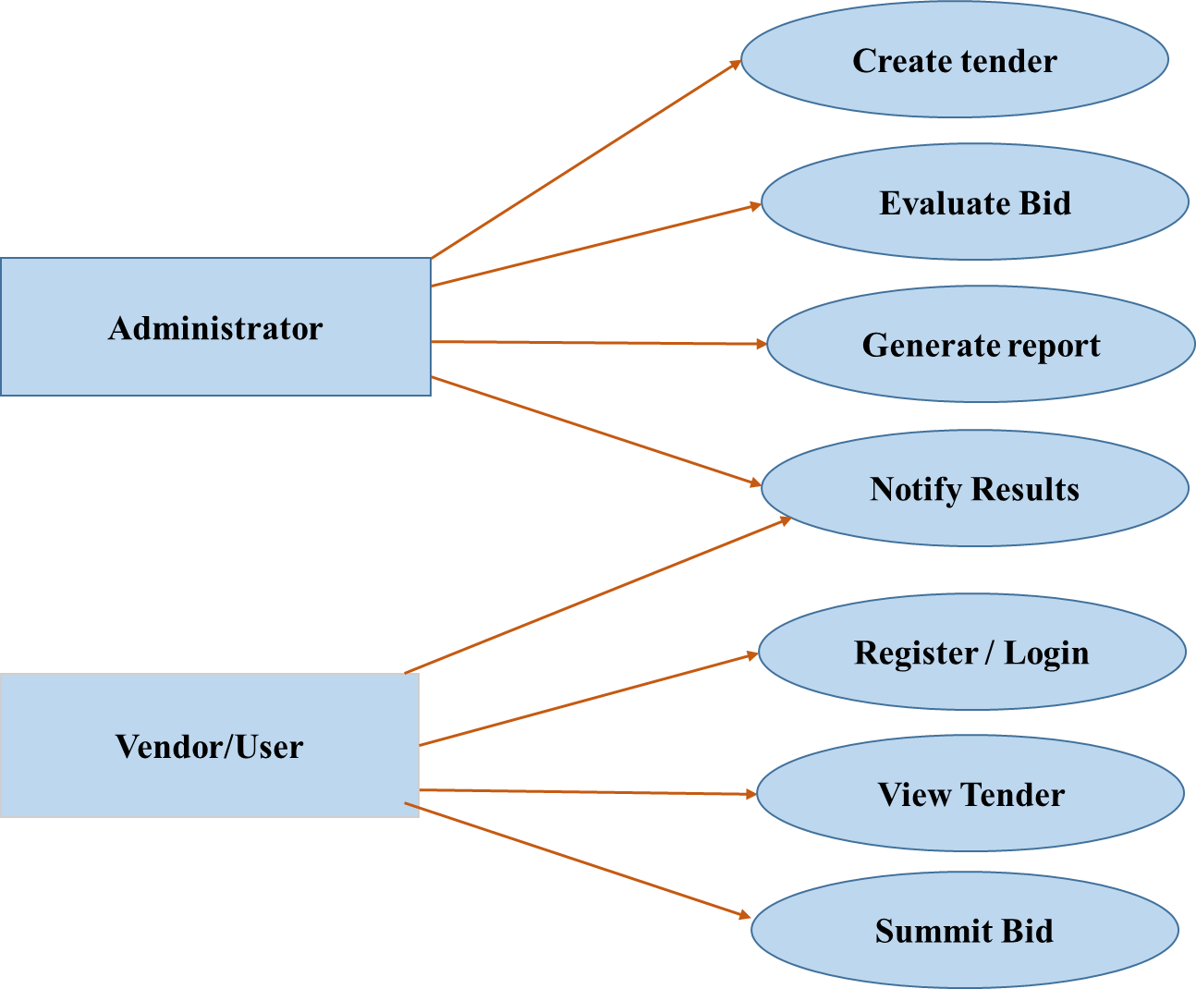
Fig 1 use case Diagram
2.4.1.2 Use Case Documentation
Each use case is described in detail, including:
Use Case Name: Submit Bid
Actor: Vendor
Description: Allows a vendor to upload and submit a bid document before the deadline.
Preconditions: Vendor is logged in and has viewed the tender
Post conditions: The bid is stored securely and cannot be modified after submission.
Main Flow:
Vendor selects a tender
Fills out the bid form
Uploads documents
Submits the bid
System confirms submission
Similar documentation should be provided for other key use cases
2.4.2 Essential UI Prototype
Prototypes offer a visual representation of the system's user interface
This includes basic layout and navigation design for key pages:
Login/Registration Page
Admin Dashboard
Tender Listing Page
Bid Submission Page
Evaluation Results Page
These low-fidelity mockups help in early validation of user experience.
Screenshots or sketches of these UI prototypes can be attached here
2.4.3 User Interface Flow Diagram
This diagram outlines the flow of actions a user can take through the system. Helps track the path from login to various actions like viewing tenders, submitting bids, and checking results.
Provides a high-level overview of system navigation.

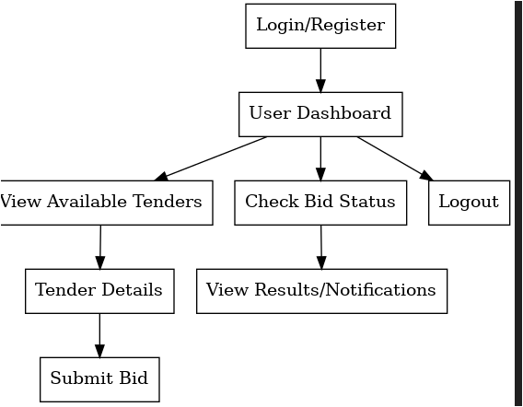
2.4.4 Supplementary Specifications
Supplementary specifications define additional system requirements that are not directly addressed within the core functional use cases. These specifications ensure that the system meets business needs, regulatory standards, user expectations, and future adaptability. They include business rules, design and implementation constraints, and potential change cases.
2.4.4.1 Business Rules
These are predefined policies, calculations, or conditions that the system must follow.
Examples:
- A vendor must be registered to submit a bid
- The tender deadline must be set at least 10 days after tender creation
- An administrator can cancel a tender only before the bid deadline
2.4.4.2 Constraints
Constraints refer to technical, legal, or design-related restrictions that affect how the system is developed, deployed, or maintained.
Types and Examples:
Technical Constraints
The system must be web-based and compatible with major browsers (Chrome, Firefox, Edge).
The backend must use MySQL or PostgreSQL for database management.
The system must support file uploads up to 10 MB, accepting only PDF formats.
Regulatory Constraints
The system must comply with the national Public Procurement and Property Administration laws.
Data related to tenders and vendors must be stored securely and retained for a minimum of 5 years.
Design Constraints
The system interface must be responsive to support both desktop and mobile users.
All communication between clients and servers must use secure protocols (HTTPS).
These constraints guide the development process and ensure the system remains within scope and compliance boundaries.
2.4.4.3 Change Case
Change cases are forward-looking scenarios that anticipate possible future requirements. Including change cases allows for designing a flexible system that can be extended or upgraded with minimal disruption. Examples: Multi-language Support: In the future, the system may be required to support multiple languages to accommodate international bidders. The system should be built with support for language packs and translation files.
E-signature Integration: Future regulations may require electronic signatures on bid documents. The system should be designed to allow integration with external e-signature APIs.
Mobile Application Support: Although the initial release will be web-based, future versions may include a mobile app. The architecture should separate business logic and interface logic to allow reuse across platforms.
Integration with Payment Systems: If a tender submission fee is introduced later, the system should allow for secure payment gateway integration. These change cases help future-proof the system and reduce the cost and effort of adding new features.
2.5 System Models – Analysis
This section focuses on analyzing the internal structure and behavior of the tender processing system. While the requirement determination phase addressed what the system should do, the analysis phase transforms those needs into technical system logic and interaction models. These models guide the design and development process and ensure that both functional and non-functional requirements are addressed in a structured and consistent manner.
2.5.1 System Use Case Modeling
System use case modeling elaborates the interactions between actors (users or external systems) and the system itself. This helps identify system functionality and how the system will respond to inputs
2.5.1.1 Use Case Diagram
The use case diagram visually represents the functional requirements and user interactions with the system. It includes all major operations a user or admin can perform
Actors: Administrator: Can create tenders, evaluate bids, manage users, and publish results
Vendor/User: Can register, view available tenders, submit bids, and track bid status
Major Use Cases:
Register/Login
Create Tender
View Tender
Submit Bid
Evaluate Bid
Notify Results
Generate Report
2.5.1.2 Use Case Documentation
Each use case is documented using a structured template to understand system behavior clearly
Example: Submit Bid
Use Case Name: Submit Bid
Actor: Vendor
Preconditions: The vendor must be logged in and the tender must be open
Post conditions: The bid is stored in the system and marked as submitted
Main Flow:
Vendor logs in
Navigates to the tender list
Selects a tender
Uploads the bid document
Clicks the “Submit” button
System confirms submission and stores data
Alternative Flow: If the tender is closed, the system displays an error message. (Repeat similar documentation for other use cases like Create Tender, Evaluate Bid, etc.)
2.5.2 Sequence Diagram
A sequence diagram shows the interaction between system components and actors in a specific time sequence. It helps clarify the flow of operations for a given use case.
Example: Submit Bid
Actors & Objects:
Vendor
Web Application Interface
Bid Controller
Database
Process Flow:
Vendor initiates login
System validates credentials
Vendor navigates to tender list
Selects a tender and uploads bid file
Bid Controller receives and validates the bid
Bid is saved to the database
System confirms successful bid submission to the vendor
2.5.3 Activity Diagram
The activity diagram illustrates the workflow or process logic for system functions. It shows parallel and sequential activities in the business process.
Example: Activity for Bid Submission
Start
Login/Register
View Active Tenders
Select Desired Tender
Upload Bid Document
Confirm Submission
Store Bid in Database
Notify Vendor
End
This helps developers and testers understand the logic behind each functional module of the system.

Chapter Three- System design
3.1 Introduction
System design transforms the requirements defined during the analysis phase into a blueprint for constructing the actual system. It serves as a critical phase in the software development life cycle (SDLC), bridging the gap between requirements and implementation. This chapter outlines the design principles, architecture, components, and models used to structure and implement the Tender Processing System efficiently, securely, and reliably.
3.2 Design Goals
The design of the Tender Processing System is guided by several critical goals to ensure that the final product meets user’s needs and system requirements effectively. These goals not only influence the architecture and structure of the system but also shape development priorities, implementation strategies and future scalability. Below are the key design goals explained in detail:
1. Scalability
The system should be able to handle increasing loads as more tenders are published, more vendors participate, and data storage grows. The architecture should support horizontal scaling (adding more servers) and vertical scaling (upgrading existing hardware) to ensure system stability under growing demand.
2. Security
Security is paramount in a system that handles confidential bids and competitive tenders. The system must:
- Encrypt sensitive data (e.g., bids, passwords)
- Use secure authentication (e.g., hashed passwords, session management)
- Implement role-based access control to restrict actions based on user roles
- Preventing common threats such as SQL injections, XSS, and CSRF attacks
3. Usability
The system should be intuitive and easy to navigate for users with different technical backgrounds, including:
- Simple registration and login processes
- Guided workflows for submitting and reviewing tenders
- Clear instructions, error messages, and feedback
- Responsive design for access via desktops, tablets, and smartphones
4. Modularity
The design should follow a modular approach by dividing the system into separate components such as user management, tender management, bidding, and reporting. This modularity:
- Improves maintainability
- Allows individual components to be tested and upgraded independently
- Enhance clarity for developers and contributors
5. Performance
- The system must be optimized to handle operations efficiently, even underload. Key performance goals include:
- Fast database queries
- Optimized server responses
- Minimal system downtime
- Load balancing for high-traffic scenarios
6. Maintainability
To ensure the system can be updated and enhanced easily:
- The codebase should follow best practices and be well-documented
- The architecture should separate concerns (MVC pattern or similar)
- There should be a clear changelog and versioning system
7. Interoperability
The system should be capable of interacting with other systems such as government procurement databases or vendor platforms, if necessary. It should use standard protocols (e.g., REST APIs) and formats (e.g., JSON, XML) for integration.
8. Reliability
The system must perform consistently over time. Mechanisms should be in place for:
- Automated data backup
- Recovery from crashes or errors
- Audit trails to track actions and changes in the system
3.3 Design Trade Offs
In the process of designing the Tender Processing System, several tradeoffs had to be carefully considered to balance performance, security, usability, cost, and maintainability. These tradeoffs involve making compromises between competing design choices to ensure the system meets its primary goals without overcomplicating the architecture or exceeding resource constraints.
1. Security vs. Performance
One of the major tradeoffs involves securing sensitive data (bids, user information) while maintaining high system performance. Implementing encryption, secure authentication, and regular audits increases system overhead, which may slightly degrade performance. However, due to the sensitive nature of procurement data, security is prioritized, and performance optimizations are made elsewhere (e.g., caching non-sensitive data, database indexing).
2. Feature-Rich Interface vs. Simplicity
The sophisticated, feature-rich user interface can enhance user experience by offering more tools and interactivity. However, such interfaces can become overwhelming for new users and are harder to maintain. In this system, the interface is designed to be simple and user-friendly, focusing on core functionality. Advanced features may be added in future versions based on user feedback.
3. Customization vs. Standardization
Allowing high levels of customization (e.g., custom tender templates, adjustable evaluation criteria) adds complexity and increases the chances of user errors. Therefore, the system uses standard templates and fixed workflows for tender submission and evaluation, ensuring consistency and reducing system errors. Limited customization options are provided in controlled areas (e.g., deadline extensions, notification settings).
4. Real-Time Functionality vs. System Load
Real-time notifications (e.g., bid submission confirmations, award notifications) improve user engagement but increase server load. To address this, the system uses asynchronous messaging and queue-based notification delivery to maintain responsiveness without compromising system performance.
5. Development Speed vs. Code Quality
Rapid development may lead to quick results but can produce technical debt. The design of this system favors code quality, clarity, and documentation over speed, ensuring the system is maintainable and extensible over time.
6. Offline Access vs. Development Complexity
Providing offline functionality (e.g., form filling without the internet) adds significant complexity and synchronization challenges. The current design assumes continuous online access, as most users will interact through web portals. Offline support may be considered for future mobile apps.
7. Single Database vs. Distributed Storage

3.4 Subsystem Decomposition
Subsystem decomposition refers to the process of breaking down a complex system into smaller, manageable, and independent components (or subsystems) that can function individually and collectively to achieve the overall goals of the system. In the Tender Processing System, this decomposition helps isolate key responsibilities, improve maintainability, and enable parallel development. Each subsystem handles a specific set of functionalities and communicates with other subsystems through well-defined interfaces. Below are the primary subsystems of the proposed system:
1. User Management Subsystem
Responsibilities:
- Handles user registration and login
- Manager’s roles: Administrator and Vendor
- Provides secure authentication and access control
Key Features:
- Password encryption and validation
- Session and token management
- User profile management
2. Tender Management Subsystem
Responsibilities:
- Allows administrators to create, publish, update, or cancel tenders
- Stores all tender details including titles, requirements, submission deadlines, and eligibility criteria
Key Features:
- Tender creation form with validation
- Auto-notification on new tender publications
- Tender status tracking (open, closed, awarded, etc.)
3. Bid Submission Subsystem
Responsibilities:
- Enables vendors to submit their bids securely
- Ensures file uploads and bid information are validated and stored
Key Features:
- File upload support (PDF, Word, etc.)
- Time-stamped submissions
- Status tracking of submitted bids
4. Evaluation and Award Subsystem
Responsibilities:
- Assist administrators in evaluating submitted bids
- Supports scoring, ranking, and selection based on pre-defined criteria
Key Features:
- Evaluation form and tools
- Automation of ranking based on weights
- Award decision and result publishing interface
5. Notification Subsystem
Responsibilities:
- Send real-time or scheduled notifications to vendors and administrators about system events
Key Features:
- Email and/or SMS alerts
- Event-triggered notifications (e.g., tender posted, bid awarded)
- Notification logs
6. Reporting and Monitoring Subsystem
Responsibilities:
- Generates reports for tenders, bids, user activity, and system performance.
Key Features:
- Exportable reports (PDF, Excel)
- Tender status reports, bid summary reports
- Logs for auditing and transparency
7. Document Management Subsystem
Responsibilities:
- Manages storage and retrieval of all uploaded tender and bid documents
Key Features:
- Document encryption and access control
- File integrity checks
- Versioning and archival of older documents
3.5 Design Phase Models
3.5 Design Phase Models
3.5.1 Class Modeling
This model defines classes, attributes, methods, and relationships:
- User: user ID, name, email, login
- Tender: tender ID, title, deadline, publish
- Bid: bid ID, amount, vendor ID, submit
3.5.2 Persistent Model
3.5.2.1 Mapping Class Diagram to Relational Model
Classes are mapped to relational tables:
- Users (user_id, name, email, password)
- Tenders (tender_id, title, description, deadline)
- Bids (bid_id, amount, tender_id, user_id)
3.5.2.2 Normalization
The database is normalized to 3NF:
- 1NF: Eliminate repeating groups
- 2NF: Remove partial dependencies
- 3NF: Eliminate transitive dependencies
3.5.3 User Interface Design
The system interface prioritizes clarity and ease of use:
- Login and registration screens
- Admin dashboard
- Tender creation and management forms
- Bid submission form
- Notifications and results panel
Design tools: Wireframes, mockups, and HTML prototypes
3.5.4 Deployment Diagram
Shows the physical distribution of components:
- Clients (browsers, mobile)
- Web server (frontend)
- Application server (business logic)
- Database server Deployment supports cloud hosting, with load balancing and backup capabilities
3.5.5 Network Design
Illustrates connectivity and security:
- SSL/TLS encryption
- Firewalls and VPN
- Role-based access controls
- Monitoring tools for traffic and intrusion the network is segmented to isolate admin access and prevent data breaches.

References
Kozik, R. (2019). The Process of the Tender Evaluation in Public Procurement for Implementation of Design Documentation. IOP Conf. Series: Earth and Environmental Science, 222(1), 2019.
World Bank. (2015). Benchmarking Public Procurement 2015: Assessing Public Procurement Regulatory Systems. Washington, DC.
- OECD. (2009). Integrity in Public Procurement: Good Practice from A to Z. Paris: OECD Publishing.
Deshpande, J. J., Gowda, M., & Dixit, M. (2018). Permissioned Blockchain Based Public Procurement System. IOP Conf. Series: Materials Science and Engineering.
Abdullahi, N. Z., Gambo, N., & Mohammad, S. A. (2019). A Framework for Ethical Procurement in Construction Projects in Nigerian Federal Universities.
UNCTAD. (2017). Developing Countries in the Digital World. United Nations Conference on Trade and Development. Public Procurement Proclamation No.649/2009, Ethiopia.

